
Mobile Life Monitor
Version 0.1
User Manual
_______________
Chate Luu
Sukit Tretriluxana

Table of Contents

What is Android Life Monitor (MLM)? 3
The “Ideas” Behind MLM 3
Get MLM Running on Your Mobile Device 3
OpenIntents 4
Android Life Monitor 4
When in Trouble 13
More to Come 21

What is Mobile Life Monitor (MLM)?
Welcome to Mobile Life Monitor (MLM)! Unlike other typical mobile applications on the Android platform, MLM is unique in that you are not expected to typically use it on a day-to-day basis. It automatically springs into action when it “senses” that you, as the mobile user, are in a possible emergency situation and may need attention immediately. When that happens, the application automatically makes phone calls to your designated emergency contact and the 911 agent if you designated so. It will also send out an email message to your emergency contact that provides additional information such as your current approximate location.

The “Ideas” Behind MLM
MLM is able to “sense” an emergency situation because it runs in the background of the mobile phone once the user has clicked to activate the application. It uses the accelerometer embedded in the Android device to detect significant impacts or sudden major movements to the mobile device that may be potentially signs of the user being in some sort of emergency trouble. A few examples are:
- Impacts from falls because the user has become unconscious.
- Impacts that are caused by an attack from something or someone (e.g. animal attacks, criminals, etc.)
- Impacts from a serious accident such as a car accident.
When the needs arrive, MLM uses the telephony and multimedia features of Android to make phone calls and playback user-recorded voice message to the callee. It also uses the constantly available network and the Global Positioning System (GPS) of the mobile device to send out the possible current location of the user via email.

Get MLM Running on Your Mobile Device
As of Android version M5rc15, there has not been a built-in emulated accelerometer with the Android emulator. As a result, OpenIntents and SensorSimulator software are used to provide emulation during development and testing of the software. The followings provide the separate installation instructions of both OpenIntents and MLM:

OpenIntents
Make sure to first install and setup configurations of OpenIntents. The software can be found at the following site:
http://code.google.com/p/openintents/downloads/list?can=1
To keep this document focused, we will not go into the details of installing the OpenIntent software. However, below are the key steps of the installation.
- Download and unpack OpenIntents version Release 0.1.4 for Android SDK m5-15 to a directory on your machine.
- Install OpenIntents.apk onto the emulator.
- Run SensorSimulator.jar from the tools directory inside the OpenIntents directory.
- Follow the instructions detailed at http://code.google.com/p/openintents/wiki/SensorSimulator to connect OpenIntents application to the SensorSimulator. Ensure that the accelerometer is enabled. Since we are using version 0.1.4, also make sure that you set the update rate of the accelerometer to 50 times per second for smooth testing.

Android Life Monitor
Follow the instructions below with your own settings to setup MLM.
- Install AndroidLifeMonitor.apk onto the emulator.
- From the main menu of the emulator, invoke the application. The screen should show up as followed.
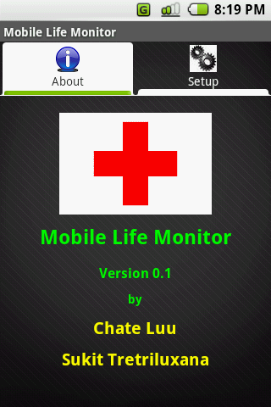
- Click on the Setup tab to reveal the configuration panel.
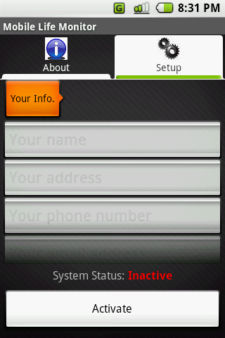
- On the configuration panel, there are 6 settings as followed that require your inputs. Note that the screen can be scrolled up and down.
  - Your personal information. This is the set of fields for entering your name, street address, phone number, email address, the password for your email account. This information is used when communicating with your emergency contact (via phone call and email) and the 911 agent. You can enter the information directly into each text fields. The faster way is to pull in the information from the Contact application, by clicking the Your Info button. This will bring up another screen shown below displaying the list of contacts you have stored:
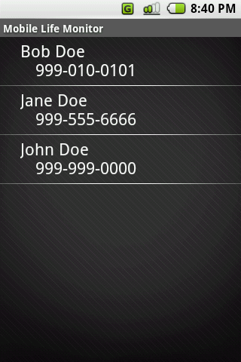
By selecting one of these contacts, MLM will automatically populate your personal info fields in the Setup screen:
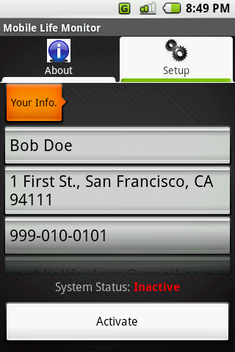
Next, enter the password associated with the email address enter:
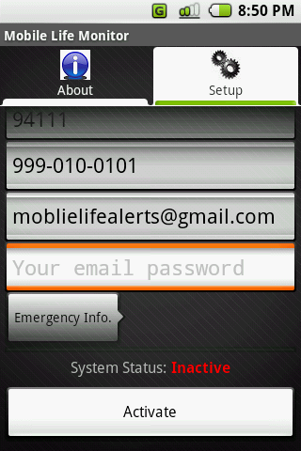 | 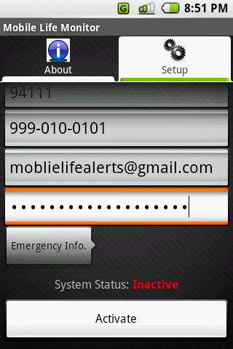

MLM uses the user personal email address and password to communicate with the SMTP server in order to send out an email message to the emergency contact on behalf of the user. It does not use this information for any other purposes.
  - Emergency information. This is similar to entering the user information above except that a password field is not required for the email account. MLM will call the contact and also send out an email message to this selected emergency contact. As before, quickly pull in the information from the Contact application by pressing Emergency Info button.
  - Call 911 if line busy? MLM will make a call to 911 if this checkbox is set and only if the call to your emergency contact does not go through (e.g. line busy).
  - Text message. This is the message that will be sent out in the email to your emergency contact. Make sure it's concise and clear to your contact.
  - Voice message. This is your own recorded voice message that will be played back when calls are made to your emergency contact and 911 agents. Similar to the text message, make sure it's clear and concise to the listener. Note that clicking Voice Message button is supposed to bring up a screen that will allow the user to record a personal emergency voice message. However, this screen is not implemented yet due to the limitation of the emulator. Clicking it now will simply pop up a notification indicating that the voice message has been successfully recorded. In this release version, the MLM application will simply use a pre-recorded voice message mimicking one that the user will have to record.
  - Sensitivity. This setting allows you to tell MLM how sensitive it should be to potential impacts that it is monitoring. The more sensitive setting will cause MLM to be more likely to believe that an emergency situation is happening to the user. When clicking Sensitivity button, the sensitivity test screen will show up as depicted below.
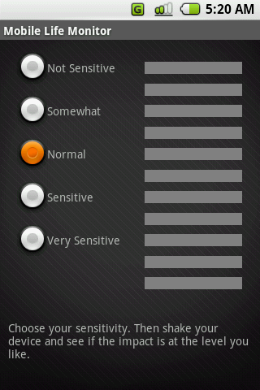
There are 5 levels of sensitivity for to choose from. Test shake the device (in SensorSimulator application window, use the mouse to grab wireframe device picture and move your mouse in different directions; the faster the greater the impact) and change the level to get a feeling of how sensitive you would like MLM to monitor. When shaking, MLM displays the impact level it detects through the LED bar on the right of the screen. If the impact meets your setting, it would display a message indicating so as shown below.
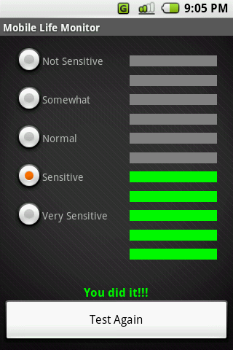
When you are satisfied with the level you want, simply press standard Back button on the device to go back to the Setup tab.
- When all the settings are filled, you are now ready to activity MLM to run in the background. This can be done by simply clicking Activate button at the bottom of the screen. If everything goes well, the system status should now say Active as shown below. Note that you can only activate MLM after all settings are filled. Once activated, the user can deactivate MLM background monitoring by clicking on the Deactivate button as shown below.
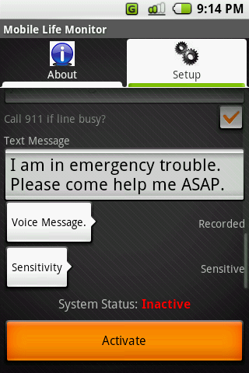 | 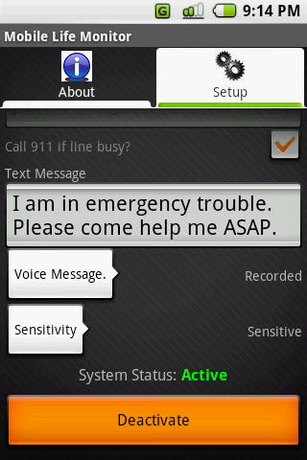

When in Trouble
After activating MLM, the user is free to do anything else. The user does not need to constantly be aware that MLM is still running on the device and is monitoring for a potential emergency situation.
Now, we are going to simulate an impact to the emulator to see how MLM works. Just follow the instructions below. At this point, it is assumed that OpenIntents SensorSimulator has also been configured as described earlier.
- Go to some other application as if you are doing something else. Maybe opening up a browser serving some sites is a good idea.
- In SensorSimulator application window, use the mouse to grab wireframe device picture and quickly move your mouse in different directions to simulate an impact. Make sure this simulation mimics at least the amount of impacts performed in the “sensitivity” configuration step done during setup process.
- If the emulated impact is strong enough, the current application will be paused, and the screen will switch to an MLM screen shown below. A voice will ask if the user is okay.
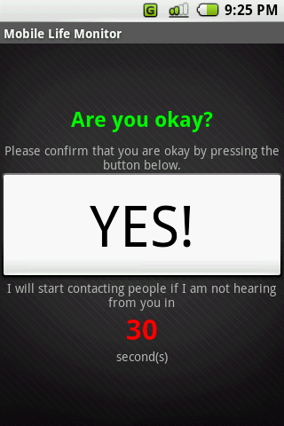
The user will get to this screen when MLM senses that a potential emergency is happening based on the Sensitivity setting. An emergency may not have happened, and this was a false alarm scenario. In this case, simply clicking on the big YES button will put MLM back to sleep again. The previous application that the user was using before the MLM emergency detection happened will resume afterward.
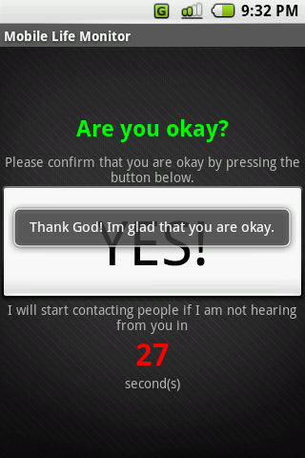
If you want to see the next MLM activity, do not click on the YES button and wait until the 30 seconds expire.
- Following step 3 if you don’t respond to MLM in 30 seconds, MLM will assume that you are really in an emergency situation. It will start calling your emergency contact next as shown below.
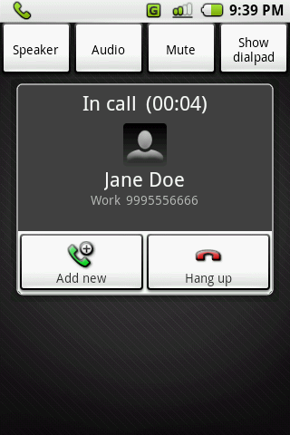
When the call starts, it plays your recorded voice message to the line so that the emergency contact party can hear your emergency message. MLM will attempt to call your contact at most 3 times. With the current version of the emulator, we cannot simulate a busy line. However, for this version and for demonstration purpose only, the code has been written such that if you press Hang up (not Return) button before 30 seconds have elapsed after the call starts, MLM will interpret this action as if the line was busy, and it will reattempt the call.
- Immediately after step 4, if your emergency contact call cannot go through (i.e. failed 3 times), and if you check Call 911 checkbox in the configuration screen, MLM will start calling 911 agents.
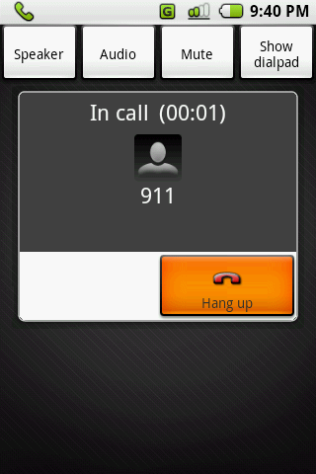
Again, the emergency voice message will be played through the line to the 911 agent, and the call will be attempted at most 3 times.
- When all call sessions are over, MLM now sends out email to your emergency contact as the screen shown below.
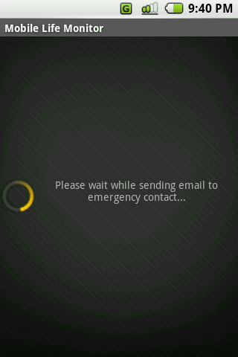 | 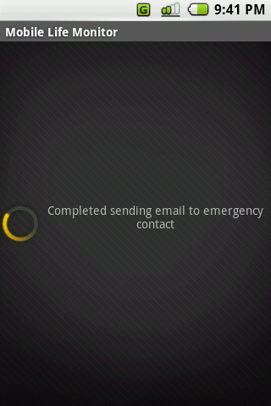

The sent email message contains the user provided emergency text message and the current location address that the mobile device appears to be at (as accurate as the GPS service allows). Here is the sample message.
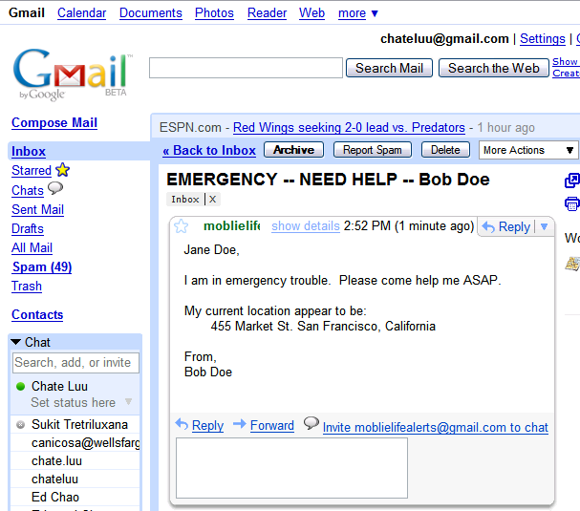
- After completing all the steps above, MLM displays the final screen summarizing the actions it has taken as the result of an emergency situation detected. Additionally, the user personal information and emergency contact information are displayed in this final screen as a reference for those who may have come to help the user. This way the device user is known and who to contact regarding the emergency situation. Some samples of this last summary screen are shown:
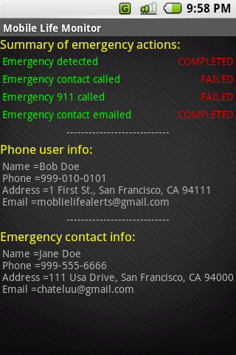 | 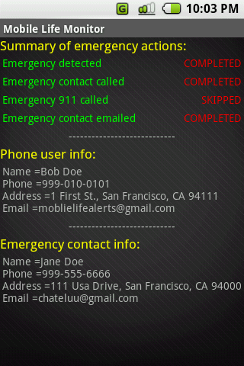
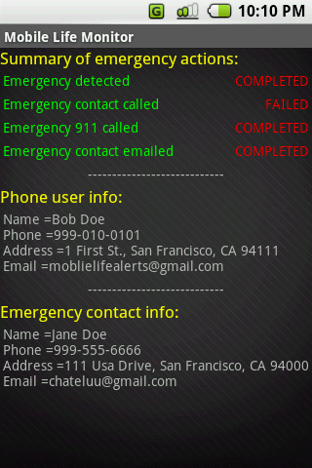

More to Come
There are a lot more ideas that we would like to add to the future versions of Android Life Monitor. Below is a sample list of these enhancements:
- Improve the accuracy of the impact detection by using other sensors such as compass, thermometer, etc. This will provide a more accurate feedback to MLM so that emergency situations can be more realistically detected. However, we need to have a real device for testing in order to get the real feeling.
- Add the health insurance information so that it can be transmitted to the hospital before or when you arrive. Such information will be helpful to the emergency staff.
- Add medical prescription information so that it can also be transmitted by or displayed on the device.
- Build the actual functionality to record the emergency voice message of the user.
- Play recorded voice message when the emergency contact or a 911 agent picks up the phone call.
- Add other channels of message communications (e.g. SMS, other emails besides Gmail, etc.)
- Immediately after an emergency situation has been detected by MLM, also “record” the environment that the user is at using the voice recorded and camera on the mobile device. Capturing such data may be helpful to explain what happened to the user during the emergency.

MLM can be extended to support any textual communication channels, such as SMS and IM. However, only email is supported in this release due to the limitation of the Android emulator.
Only accelerometer is currently used. In a future version, inputs from compass, thermometer, or other means will be taken into account for a more accurate detection.
For downloadable components and additional information, see http://code.google.com/p/openintents/
For download and more information, see http://code.google.com/p/openintents/wiki/SensorSimulator
Only Gmail is currently supported. Other SMTP-accessible email system will be supported in a future release version.
This text will also be used for other types of textual communication channels (e.g. SMS, IM) in future releases.
This is an unfortunate situation. Hopefully we will have a more capable emulator soon that we can better showcase this feature.
Some might feel that the impact is not so realistic. We agree to that. Straight off the bat, we cannot make the shaking detection realistic without a real physical hardware device.
Again, as mentioned earlier, the user cannot record a voice message because the emulator does not support voice recording. The voice message you are hearing is a prerecorded one that we ship with MLM for this version.
In reality, if the line is busy, MLM will not play the voice message yet. It will wait until the line is actually on.
The emulator currently doesn’t have real GPS functionality. Thus, the current address info you see now is just a mockup. Whenever we have the real GPS functionality, we are going to have the real current address here.

